Purpose: This SOP defines procedures and documentation that must be completed in the event that:
- A biological spill up to Biosafety Level 2 with enhanced precautions occurs
- An individual is exposed to a potentially injurious biological agent as defined in the Risk Assessment Form prior to sorting

NOTE: Spill Procedures should be clearly posted in the BSL-2 suite

Scope: This procedure is to be utilized for all Health Science Center (HSC) Flow Cytometry Core Facility laboratory safety practices and procedures at the University of Utah.

Contents:
1.0 Introduction
2.0 Spill Containment and Disposal
3.0 Exposure First Response
4.0 Post Exposure Medical Care and Documentation
5.0 Post spill or exposure documentation and reporting
6.0 Appendices

Cross Referenced Documents:
University of Utah Flow Cytometry Core Facility SOP22
University of Utah Flow Cytometry Core Facility Risk Assessment Form
University of Utah Office of Environmental Health and Safety Post Exposure SOPs
Spill or Exposure Event Report
Employer’s First Report of Injury Form (E1-122)

Terms used in this document or other related safety documents:
IBC = Institutional Biosafety Committee
BSC = Biosafety Cabinets (defined as Class I, II or III)
BSL = Biosafety Level (defined as 1, 2, 3 or 4)
BSL2+= BSL2 with enhanced precautions
PPE = Personal Protective Equipment
OEHS= Office of Environmental Health and Safety
NIH= National Institutes of Health
NIH OSP= National Institutes of Health Office of Science Policy
PBBP= Program of Biosecurity and Biosafety Policy
RG= Risk Group
PI= Principal Investigator
- Introduction
Personnel of the Flow Cytometry Core Facility at the University of Utah may encounter various microorganisms, viruses, and viral vectors. Work with any infectious agents at Risk Group II or higher requires completion of a Risk Assessment Form, review and approval by the University of Utah Institutional Biosafety Committee (IBC) or Biosafety Office, as well as approval by the facility director. After work is approved, all samples must be handled following the guidelines in SOP 22 for BSL2+ cell sorting; however, accidents, such as spills and other exposures, may result in a breach of normal containment scenarios. Individuals put at risk in these instances must have guidelines for what constitutes an exposure and where to seek appropriate medical care. As a result, this SOP defines proper containment, disposal, and documentation of such events.

- Spill Containment and Disposal
If a biological sample is spilled, the spill must be immediately contained and disposed of. After cleanup, the potential exposure risk of the spill must be assessed and reported to the appropriate offices. All spills or breaks involving recombinant DNA or synthetic nucleic acid molecules and potentially hazardous biological materials should be cleaned up using appropriate biosafety procedures, described below. If there is any doubt about what to do, call the Biosafety Office at 1-6590, or the University’s internal emergency number at 5-2677. In addition, if the spill is large or outside of designated bio-containment equipment (e.g. BSC, bioBubble, centrifuge safety-cups, etc.), secure and cordon off the area, and notify the lab supervisor or PI and Biosafety Office immediately.

  - Surface Spills
    - Stop work
    - Dispose current pair of gloves, don two layers of disposable gloves
    - If outside the biosafety cabinet, don safety glasses or face shield.
    - Contain the spill by covering with paper towels to avoid generating splashes or aerosols
    - Saturate spill with freshly-made 10% bleach, and let sit for a minimum of 30 minutes
    - Wipe up spill, disposing of towels in biohazard bag
    - Wipe spill area again with fresh 10% bleach, as well as 70% ethanol and dH₂O to remove bleach residue
    - Wash hands with soap and water

  - Spills Inside of a Centrifuge Contained Within a Closed Cup, Bucket, or Rotor
    - Put on a lab coat, two pairs of gloves, and proper eye protection prior to opening the centrifuge. Open carefully to assess the damage.
    - If the spill is contained within a closed cup, bucket, or rotor, spray the exterior with fresh 10% bleach and allow a minimum of 30 minutes of contact time. Remove the carrier to the nearest biosafety cabinet (BSC).
    - If a BSC is available, gather the supplies needed, such as a sharps container for broken glass and bins filled with disinfectant. Place the supplies inside the BSC. Use a device (forceps, tongs, etc.) to safely remove broken glass, and place it directly into a sharps container. Carefully remove any unbroken tubes and place them in a tube rack where they can be sprayed with 10% bleach. Wipe carrier/bucket with 10% bleach, followed by dH2O to remove bleach residue. Soak contaminated supplies in 10% bleach for at least 30 minutes.
    - After disinfection, carrier, bucket, or rotor should be washed with a mild soap and water.
    - Spray the interior of the centrifuge chamber with 10% bleach let sit for a minimum of 30 minutes, followed by cleaning with dH2O to remove the bleach residue.
    - Dispose of all clean-up materials (except sharps) in an appropriate biohazardous waste container. Dispose of sharps in a biohazard sharps container.
    - Remove personal protective equipment and thoroughly wash hands.
    - Notify lab supervisor or PI.

  - Broken Glass or other sharps objects
    - Stop work
    - Dispose current pair of gloves; don two layers of disposable gloves
    - If outside the biosafety cabinet, don safety glasses or face shield.
    - Do not pick up glass or sharps with hands. Use a hard dustpan with forceps or broom to collect glass or sharps.
    - Dispose of broken glass or sharps in a proper sharps container.
    - Wash hands with soap and water
    - Notify the lab supervisor or PI

  - Emergency Spills: Environmental Risk
    - Stop work
    - Remove PPE
    - Evacuate area
    - Notify lab supervisor or PI, and Biosafety Officer or OEHS
    - Take appropriate precautions to limit exposure or spread of spill to other areas

- Exposure
Exposure may occur as a result of a spill or as an accident during normal biocontainment in sample handling, via the modes described below. See Appendix 6.1 for definitions of exposure. Proper procedures in the event of exposure are defined below. If resultant injury is serious or life threatening, go to the University of Utah Hospital Emergency Department or call an ambulance (911).

  - Exposure to skin or clothing
    - Stop work.
    - Remove PPE
    - Remove contaminated clothing and wash the affected area thoroughly with soap and water, but do not abrade skin in the process.
    - If necessary, exit the lab area and immediately take a shower. Wash thoroughly with soap and water, but not hard enough to cause skin abrasions.
    - Notify the lab supervisor or PI
    - If exposed to BSL-2/RG2 (or above) agent, notify the Biosafety Officer

  - Penetrating wounds via syringes or potentially contaminated sharps
    - Stop Work.
    - Remove PPE
    - Wash immediately with soap and water.
    - Notify lab supervisor or PI, who must notify the Biosafety Officer.
    - Seek appropriate medical care as described in 4

  - Eyes, or mucous membrane exposure
This kind of exposure to skin, eyes, or mucosal membranes may result from a variety of routes including but not limited to ingestion of liquid suspension of an infected material or by contaminated hand-to-mouth contact, or inhalation of infectious aerosols.
    - Stop work.
    - Remove PPE
    - Immediately flush eyes or mucous membrane with water for 10-15 minutes at an eye-wash station.
    - Notify lab supervisor or PI, who must notify the Biosafety Officer.
    - Seek appropriate medical care as described in section 4.

- Post Exposure Medical Care and Documentation
  - Go immediately to the RedMed Employee Health Clinic at the University Union Building or the Occupational Medical Clinic at the Redwood Health Center for medical evaluation and follow-up; contact information and locations in Appendix 6.2. After 5pm, you will be seen by an Urgent Care Physician. After 8pm, or if the injury is serious/life threatening, go to the U of U emergency room.

    - Bring a filled out copy of the OEHS Post Exposure SOP (can be found at https://oehs.utah.edu/resource-center/forms under “Biological Materials Exposure Procedures”at the end of this document.
    - Inform the Healthcare Provider of any medical conditions, such as pregnancy or immunosuppression, and any current medications. The healthcare provider must have this information to evaluate you and to develop a proper post-exposure plan.
    - Opt for and receive any care or prophylaxis recommended by the physician.
    - Follow up with the physician at Occupational Medicine, as requested.
    - Fill out the Employer’s First Report of Injury (E1-122 Form) This form can be downloaded from the human resources website (https://www.hr.utah.edu/forms/index.php) under “Other Forms.” Email completed E-1 to Employee.Health@hsc.utah.edu
    - After medical care, immediately report the incident to the Biosafety Office (801-581-6590) or biosafety@ehs.utah.edu as described in section 5.

- Post Spill or Exposure Documentation
Refer to Appendix 6.3 for exposure incident reporting guidelines. The PI or Supervisor of the lab in which the incident occurred is responsible for completing the Spill or Exposure Event Report as soon as possible following the incident. The Spill or Exposure Even Report can be found in Appendix 6.3 or completed online at https://oehs.utah.edu/resource-center/forms/spills-and-exposures-procedures-r-dna. The completed report must be sent to the Biosafety Office (801-585-6590) or biosafety@ehs.utah.edu.
- Appendices
  - Definitions of Exposure
Definition of Exposure
- Direct skin, eye, or mucosal membrane exposure to the agent or materials potentially containing the agent, such as tissue culture media or cells, or bodily fluids from infected animals.
- Parenteral inoculation by a syringe needle or other contaminated sharp (needlestick),
- Ingestion of liquid suspension of an infected material or by contaminated hand-to-mouth exposure, or
- Inhalation of infectious aerosols.

  - Locations and contact information for RedMed, Urgent Care Clinic, Occupational Medicine Clinic, and the University of Utah Emergency room in the event of an exposure incident.
RedMed Employee Health Clinic
200 Central Campus Dr.
Salt Lake City, UT 84112
Phone: (801) 213-3303
Hours: M-TH: 8:00AM – 5:00PM, Friday: 9:00AM – 3:30PM

Redwood Health Center
Occupational Medicine Clinic
1525 West 2100 South
Salt Lake City, UT 84119
Phone: (801) 213-9777
Hours: M-F 8:00AM – 5:00PM

Redwood Urgent Care
1525 West 2100 South
Salt Lake City, UT 84119
M-F 5:00PM – 8:00PM
Sat.-Sun.: 9:00AM – 8:00PM
(801) 213-9700

After 8 PM
Emergency Department at University Hospital
(main floor northeast side of the hospital)
50 N. Medical Drive
Salt Lake City, UT 84132
(801) 581-2292

Maps of Occupational Medicine Clinics
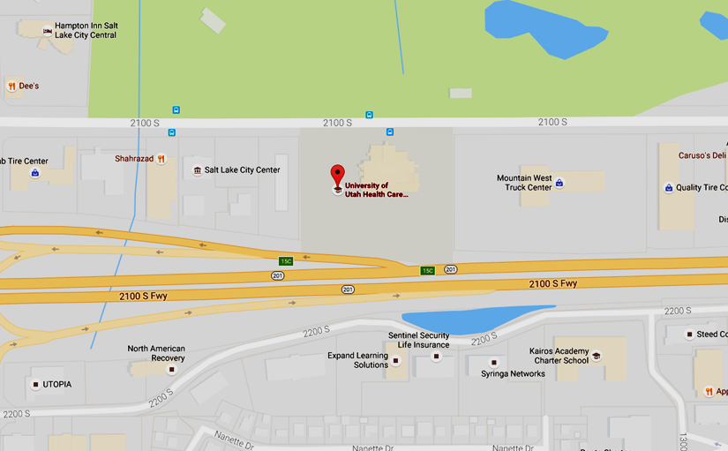

UNIVERSITY OF UTAH REDWOOD HEALTH CENTER OCCUPATIONAL MEDICINE
1525 W. 2100 S. Salt Lake City UT, 84119

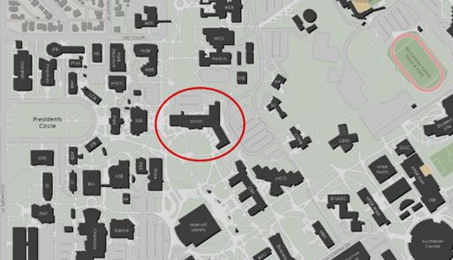
REDMED EMPLOYEE HEALTH CLINIC
200 Central Campus Dr. Salt Lake City, UT 84112

  - SPILLS OR EXPOSURE EVENT REPORTING PROCEDURE
Any significant problems, violations of the NIH Guidelines, or any significant research-related accidents and illnesses must be reported to the IBC so that a report can be sent to the NIH Office of Science Policy (OSP) within 30 days. Certain types of accidents must be reported on a more expedited basis. Spills or accidents in BL2 laboratories resulting in an overt exposure must be immediately reported to the IBC and PBBP. Spills or accidents occurring in high containment (BL3 or BL4) laboratories resulting in an overt or potential exposure must be immediately reported to OSP.
Any spill or accident involving recombinant or synthetic DNA research that leads to personal injury or illness or to a containment breach must be reported to the IBC and OSP. These events might also include skin punctures with needles containing recombinant or synthetic DNA, the escape or improper disposition of a transgenic animal, or spills of high-risk recombinant materials occurring outside of a biosafety cabinet. Failure to adhere to the containment and biosafety practices articulated in the NIH Guidelines must also be reported to IBC and OSP.
In addition, exposure to infectious agents or other potentially infected material should be reported to the IBC.
Minor spills of low-risk agents not involving a containment breach that were properly cleaned and decontaminated generally do not need to be reported. If the PI or other staff are uncertain whether the nature or severity of the incident warrants reporting, contact the Biosafety Officer, who can assist in making this determination with guidance from OSP, if necessary.

Please complete the form below and submit to the Biosafety Officer (801-581-6590)

Do we need to fill this out too???? Why are there two incident reporting forms? Email Biosafety office!!!
https://oehs.utah.edu/resource-center/forms/recombinant-dna-and-synthetic-nucleic-acid-incident-reporting-template

SPILL OR EXPOSURE EVENT REPORT

If a spill or exposure to Recombinant DNA or Synthetic Nucleic Acid Molecules, Infectious Agents or Other Potentially Infected Material occurs in your laboratory, please complete the following information and give to the Biosafety Officer. This will serve as a record of the event and be used for NIH OSP reporting, if necessary.
Date of Event:
Principal Investigator:
IBC Registration #:
Building/Room #:

Location with room (bench, biosafety cabinet, centrifuge, etc.):
Is this work NIH funded?
- If yes, please provide the grant number, NIH funding institute or center, NIH program officer contact information (name, email etc):
Type of Event (Spill, puncture wound, etc.):

Names of lab personnel involved/exposed:

- Sites of exposure (eye, mouth, etc: If applicable):

Agent (Recombinant Lentivirus, recombinant adenovirus, HIV, Unknown etc);
- Gene encoded by vector:
- Known Oncogene or predicted to increase risk of oncogenesis (Y or N):
- Containment Level (BSL-2-enhanced, BSL-2, etc)
- Amount exposed (pfu, µl, etc: if known):
Narrative of post exposure/spill response (please describe disinfectant agents, washing of exposed sites, PPE worn during clean up, etc.):

Did the affected individuals need medical treatment and, if so, where were they treated?
Date submitted to Biosafety Officer:

